

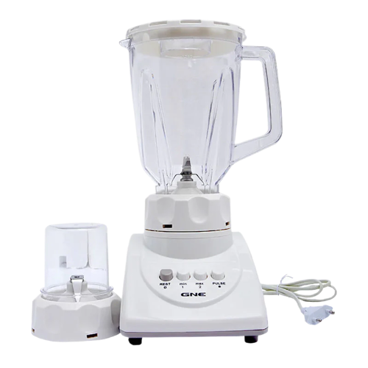

# Gaba National GN-2817/18 2 in 1 Blender & Grinder

• 2-in-1 Convenience: Seamlessly blend and grind with a single appliance.

• Compact & Stylish: Space-saving design with modern aesthetics.